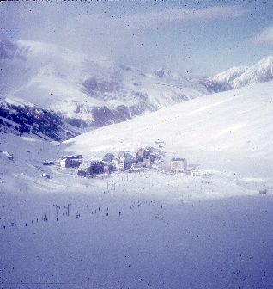
System:Directory='C:/Users/hdelangautier/Documents/Debug/1971'
System:FileName='19710402_000001.jpg'
ExifIFD:DateTimeOriginal='1971:04:02 00:00:01'
Unknown:CreateDate='-'
Unknown:XPKeywords='-'
Unknown:Artist='-'
Unknown:location='Pas de la Case - GPS position 42° 32’ 34.48" N, 1° 44’ 10.94" E'
local:Device='Epson'
local:Size='1424 kB - 3315x3508 pixels - 300x300 dot/inches'
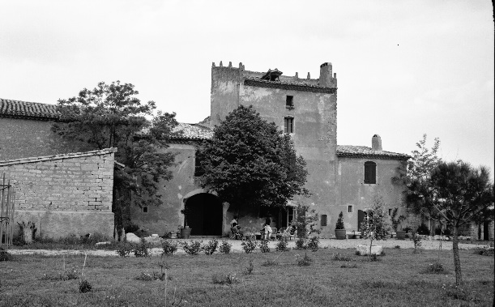
System:Directory='C:/Users/hdelangautier/Documents/Debug/1975'
System:FileName='eng168.jpg'
ExifIFD:DateTimeOriginal='2016:11:06 16:37:34'
ExifIFD:CreateDate='2016:11:06 16:37:34'
Unknown:XPKeywords='-'
Unknown:Artist='-'
Unknown:location='-'
local:Device='-'
local:Size='1364 kB - 3508x2176 pixels - 300x300 dot/inches - Horizontal (normal)'

